Enzyme Inhibitors – Module 2
Resource A – Observing the effects of inhibitors
Complete Module 1 – Introduction to enzymes before starting this Module.

Activity 1
Watch the video by Alex Bell https://www.youtube.com/watch?v=6oNb4VEvy8I and complete the questions.

Summarise the information in the video into 2/3 main points for each type of inhibitor.

Competitive Inhibitors | Non-competitive Inhibitors

The most important piece of information from the video was:

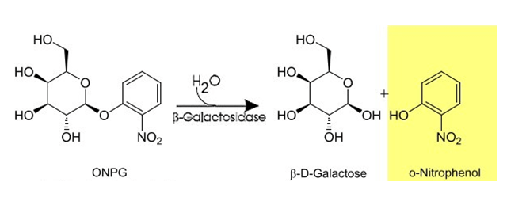
Recall the experimental reaction examined in Module 1:

Following the experiment completed in Module 1, the researcher had been informed that Chemical X interfered with the action of β-galactosidase. They prepared the following reaction tubes:
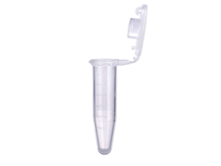
Tube 1 Tube 2 Tube 3 Tube 4
100μL X 100μL X 100μL X 100μL X
2.5μL ONPG 10μL ONPG 25μL ONPG 50μL ONPG
97.5μL buffer 90μL buffer 75μL buffer 50μL buffer
25μL enzyme 25μL enzyme 25μL enzyme 25μL enzyme

The reaction progressed for several minutes before a sample from each tube was placed into the assay plate for examination in the spectrophotometer. The sample from Tube 1 was placed in well C1, Tube 2 in C2 etc.

Activity 2
Assume Chemical X is an inhibitor, use colouring pencils to show your prediction of the results in the diagram below.

The experiment was completed 2 times with the results shown below.

 | Tube 1 | Tube 2 | Tube 3 | Tube 4
Trial 1 | 0 | 0.164 | 0.479 | 0.519
Trial 2 | 0 | 0.189 | 0.455 | 0.503

Activity 3
Use the data from Module 1 and Module 2 to draw conclusions on the nature of Chemical X. Justify your conclusions using definitions and reference to primary data.

Cognitive Verb and Sentence starters
Cognitive Verb | QCAA Definition | Sentence Starters
Summarise | give a brief statement of a general theme or major point/s; present ideas and information in fewer words and in sequence | The main idea of…..was….
Predict | give an expected result of an upcoming action or event; suggest what may happen based on available informatio | n/a
Conclude/Deduce | reach a conclusion that is necessarily true, provided a given set of assumptions is true; arrive at, reach or draw a logical conclusion from reasoning and the information given | An examination of all of the data allows the following conclusion to be drawn……

